Florida Gulf Coast University
U. A. Whitaker College of Engineering

BME 3506C Circuits for Bioengineers
Fall 2025
Exam #2 (Practice)

Name

You have 75 minutes to complete this exam. The questions should not take long to answer if you know the material. I recommend that you first read all the problems so that you can think about it as you work on other problems. Do the easer ones first so that you get the majority of the exam complete early.

You are not to use any other electronic device besides your calculator.

There are some equations on the last page that you may find helpful.

Circle your answers.

Turn off your phone, laptop, I-pad, I-pod, and any other electronic device.

- Compute the capacitance of a capacitor if we have two plates separated by a thin piece of mica. The plates measure 3cm by 10cm and the mica has a thickness of .1mm and a relative dielectric constant of $ϵ_{r}=7.$ Recall, you must use ${ϵ=ϵ}_{r }ϵ_{o}$ where $ϵ_{o}=8.85 X {10}^{-12}.$
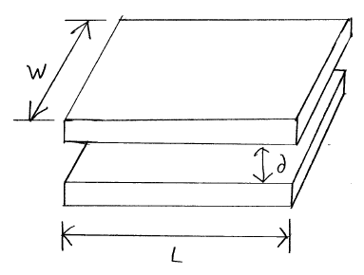

- For the following circuit,
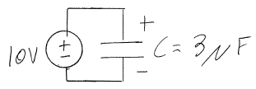
  - Compute the charge stored in the capacitor.

  - Compute the energy stored in the capacitor.

- Assume the following circuit has no energy stored in any of its devises before the switch closes. At $t=0$ the switch closes.
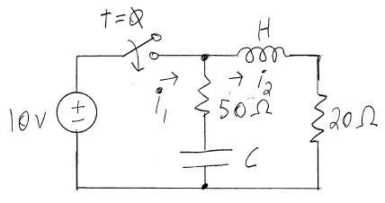
  - Compute the current $i_{1}$ and $i_{2}$ right at $t=0$.

  - Compute the current $i_{1}$ and $i_{2}$ after a long, time at $t=∞$.

- Compute the two mesh current equations and do not simplify or try to solve. The term M is the mutual inductance.

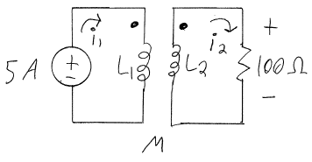
- Given the following circuit, determine for . Assume the capacitor has no charge for . At the switch closes. The solution is of the form . You are to determine the constants.

- Given the following circuit, determine for . Assume the capacitor has no charge for . At the switch closes. The solution is of the form . You are to determine the constants.

- Given the following circuit, assume $V(t)=-10v$ for $t<0$. At $t=0$ the switch closes.
- Determine for . Hint: the solution is NOT of the exponential form. Find the integral form of the solution and evaluate the integral.

- Determine .

- Determine the charge on the capacitor.

- Simplify the following circuits.
- Given the following circuit, find the equivalent capacitance.

- Reduce the circuit so that it has minimal components.

- Given the following circuit, find the equivalent circuit with minimal components.
Units
1 watt = 1 joule / second
1 volt = 1 joule / coulomb
1 amp = 1 coulomb / second
1 ohm = 1 volt / amp
1 Farad = 1 coulomb / volt
1 Henry = 1 second / amp

Equations related to the devise
 | Resister | Capacitor | Inductor
Voltage | $$v=iR$$
Current |  | 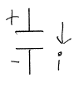 | 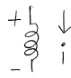
Energy |  | $$w=\frac{1}{2}Cv^{2}$$
Charge
Time Constant  $τ$ |  | $$τ=RC$$ | $$τ=\frac{L}{R}$$
Physical Properties
Components in series | $$R_{eqv}=R_{1}+R_{2}$$ | $$C_{eqv}=\frac{1}{\frac{1}{C_{1}}+\frac{1}{C_{2}}}$$ | $$L_{eqv}=L_{1}+L_{2}$$
Components in parallel | $$R_{eqv}=\frac{1}{\frac{1}{R_{1}}+\frac{1}{R_{2}}}$$ | $${C_{eqv}=C}_{1}+C_{2}$$ | $$L_{eqv}=\frac{1}{\frac{1}{L_{1}}+\frac{1}{L_{2}}}$$

If $f\left(t\right)=ke^{st}$ then $\frac{d}{dt}f\left(t\right)=kse^{st}=sf(t)$. If $s<0$ then $f\left(0\right)=k and f\left(∞\right)=0.$
If $f\left(t\right)=k_{1}+k_{2}e^{st}$ then $\frac{d}{dt}f\left(t\right)=sf\left(t\right)-sk_{1}$. If $s<0$ then $f\left(0\right)=k_{1}+k_{2} and f\left(∞\right)=k_{1}.$

